* 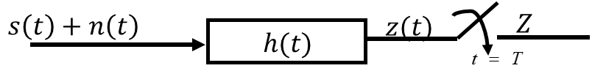**Matched Filter System Model**

$$\text{information signal pulse} s\left(t\right)$$

$$\text{background (AWGN) noise} n\left(t\right)$$

$$\text{filter impulse response} h\left(t\right)$$

$$z\left(t\right)=s_{f}\left(t\right)+n_{f}\left(t\right)$$

where

$$s_{f}\left(t\right)=h\left(t\right)*s\left(t\right)$$

$$n_{f}\left(t\right)=h\left(t\right)*n\left(t\right)$$

Decision variable $Z=z\left(t=T\right)=s_{f}\left(T\right)+n_{f}\left(T\right)$

Design Goal: Find $h\left(t\right)$ which maximizes the signal to noise given as

$$γ=\frac{{\left|s_{f}\left(T\right)\right|}^{2}}{\text{E}\left[{\left|n_{f}\left(T\right)\right|}^{2}\right]}$$

* **Signal to Noise Ratio (SNR)**
$$s_{f}\left(T\right)={\left.h\left(t\right)*s\left(t\right)\right|}_{t=T}={\left.\int_{-∞}^{∞}{H\left(f\right)S\left(f\right)e^{j2πstf}}df\right|}_{t=T}=\int_{-∞}^{∞}{H\left(f\right)S\left(f\right)e^{j2πsTf}}df$$

$$\text{E}\left[{\left|n_{f}\left(T\right)\right|}^{2}\right]=\text{power of} n_{f}\left(t\right)∵n \text{is ergodic}=\text{total area of PSD of} n_{f}\left(t\right)$$

$$\text{PSD of} n_{f}\left(t\right)={\left|H\left(f\right)\right|}^{2}⋅\text{PSD of} n\left(t\right)=\frac{N_{0}}{2}{\left|H\left(f\right)\right|}^{2}∴\text{E}\left[{\left|n_{f}\left(T\right)\right|}^{2}\right]=\frac{N_{0}}{2}\int_{-∞}^{∞}{{\left|H\left(f\right)\right|}^{2}}df$$

$$γ=\frac{{\left|s_{f}\left(T\right)\right|}^{2}}{\text{E}\left[{\left|n_{f}\left(T\right)\right|}^{2}\right]}=\frac{{\left|\int_{-∞}^{∞}{H\left(f\right)S\left(f\right)e^{j2πsTf}}df\right|}^{2}}{\frac{N_{0}}{2}\int_{-∞}^{∞}{{\left|H\left(f\right)\right|}^{2}}df}$$

* **Find Maximum of SNR**
$$H_{\max{γ}}=\underset{H\left(f\right)}{argmax}{γ}=\underset{H\left(f\right)}{argmax}{\frac{{\left|\int_{-∞}^{∞}{H\left(f\right)S\left(f\right)e^{j2πsTf}}df\right|}^{2}}{\frac{N_{0}}{2}\int_{-∞}^{∞}{{\left|H\left(f\right)\right|}^{2}}df}}$$

$$\int_{-∞}^{∞}{x\left(t\right)y^{*}\left(t\right)}dt \text{is maximized when} x\left(t\right)=ky\left(t\right) \text{where} k=\text{Natural Number}$$

$$∴\int_{-∞}^{∞}{H\left(f\right)S\left(f\right)e^{j2πstf}} \text{is maximized when}$$

$$H\left(f\right)=k{\left[S\left(f\right)e^{j2πTf}\right]}^{*}=kS{\left(f\right)}^{*}e^{-j2πTf}$$

* **Matched Filter**

$$H_{\max{γ}}\left(f\right)=kS{\left(f\right)}^{*}e^{-j2πTf}\underset{→}{F^{-1}}h_{\max{γ}}\left(t\right)=ks^{*}\left(T-t\right)$$

The filter with an impulse response $h_{\max{γ}}\left(t\right)$ maximizes the signal to noise ratio. This filter is called ‘Matched Filter’.

* NSR of Matched Filter

$$γ_{\text{max}}=\frac{{\left|\int_{-∞}^{∞}{H\left(f\right)S\left(f\right)e^{j2πsTf}}df\right|}^{2}}{\frac{N_{0}}{2}\int_{-∞}^{∞}{{\left|H\left(f\right)\right|}^{2}}df}=\frac{{\left|\int_{-∞}^{∞}{kS{\left(f\right)}^{*}e^{-j2πTf}S\left(f\right)e^{j2πsTf}}df\right|}^{2}}{\frac{N_{0}}{2}\int_{-∞}^{∞}{{\left|S{\left(f\right)}^{*}e^{-j2πTf}\right|}^{2}}df}=\frac{{\left|\int_{-∞}^{∞}{k{\left|S\left(f\right)\right|}^{2}}df\right|}^{2}}{\frac{N_{0}}{2}\int_{-∞}^{∞}{{\left|kS{\left(f\right)}^{*}\right|}^{2}⋅{\left|e^{-j2πTf}\right|}^{2}}df}=\frac{{\left|\int_{-∞}^{∞}{k{\left|S\left(f\right)\right|}^{2}}df\right|}^{2}}{\frac{N_{0}}{2}\int_{-∞}^{∞}{{\left|kS{\left(f\right)}^{*}\right|}^{2}}df}=\frac{\int_{-∞}^{∞}{{\left|S\left(f\right)\right|}^{2}}df}{\frac{N_{0}}{2}}=\frac{2E_{S}}{\frac{N_{0}}{2}} \\ ∵\int_{-∞}^{∞}{{\left|S\left(f\right)\right|}^{2}}df=\int_{-∞}^{∞}{{\left|s\left(t\right)\right|}^{2}}dt=E_{S} \text{(Parseval theorem)}$$

The matched filter is determined by the employed pulse shape. However, the performance (output SNR) of matched filter does not depend on the employed pulse shape. It depends only on the employed Energy.

* **Pulse Shaping Process**

Consider a system that transmit the consecutive data pulses with a pulse $h_{t}\left(t\right)$.

$$x\left(t\right)=\sum_{n=0}^{∞}{x_{n}h_{t}\left(t-nT\right)}$$

where $x_{n}$ are data symbol sequences and $T$ is symbol duration.

* **Delta(Impulse) Modulation**
$$x\left(t\right)=\sum_{n=0}^{∞}{x_{n}h_{t}\left(t-nT\right)}=\sum_{n=0}^{∞}{x_{n}h_{t}\left(t\right)*δ\left(t-nT\right)}=h_{t}\left(t\right)*\sum_{n=0}^{∞}{x_{n}δ\left(t-nT\right)}=h_{t}\left(t\right)*\text{delta modulation of} x_{n}$$

* **Overall System: Tx, Channel and RX**

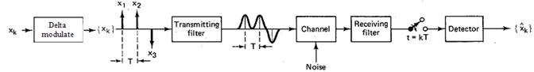

Impulse response $h_{t}\left(t\right)$ from Transmitting filter and $h_{c}\left(t\right)$ from Channel and $h_{r}\left(t\right)$ from Receiving filter.

Therefore, equivalent system is

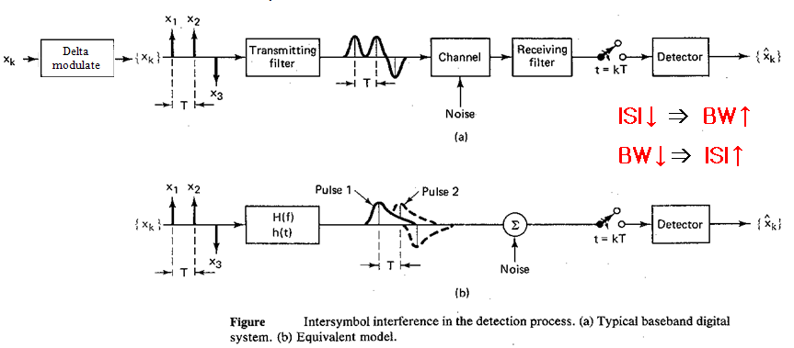

where $h\left(t\right)$ is $h_{t}\left(t\right)*h_{c}\left(t\right)*h_{r}\left(t\right)$.

* **Inter-Symbol Interference (ISI)**

The pulses are overlapped and thus, the detected symbol sequence is

$${\hat{x}}_{k}=x_{k}+n_{k}+\sum_{i≠k}{α_{i}x_{i}}$$

where the term $\sum_{i≠k}{α_{i}x_{i}}$ is called ISI.

* **Pulse Shape Design**

Use a very short pulse to avoid ISI but large bandwidth (BW).

Pulse shape design issues are no ISI and BW as small as possible

Therefore, ISI free condition is $h(zT)$ (where $z∈Z-\left\{0\right\}$) are all 0, i.e. $h\left(t\right)$ crosses 0 where $t$ is all integer (except 0) multiples of symbol duration $T$.



* **Mathematical Setup for ISI Free Condition.**

$$h\left(t\right)\underset{→}{t=kT}δ\left(k\right)$$

where $h\left(t\right)$ is ISI free pulse.

Then the spectrum of sampled $h\left(t\right)$ is

$$\sum{H\left(f+zR_{s}\right)}$$

where $R_{s}=1/T$, i.e., symbol rate.

Consequently, ISI free condition in frequency domain $\sum{H\left(f+zR_{s}\right)}$ should be equal to spectrum of impulse, i.e., a constant.

* **Raised Cosine (RC) Pulse**

$$H_{RC}\left(f\right)=\left\{\begin{aligned}1, &\text{for} \left|f\right|<2W_{0}-W \\ \cos^{2}\left(\frac{π}{4}⋅\frac{\left|f\right|+W-2W_{0}}{W-W_{0}}\right), &\text{for} 2W_{0}-W<\left|f\right|<W \\ 0, &\text{for} \left|f\right|>W\end{aligned}\right.$$

where

$$W_{0}=\frac{1}{2T}=\frac{R_{s}}{2}\left[\text{Hz}\right] \text{Nyquist minimum bandwidth}$$

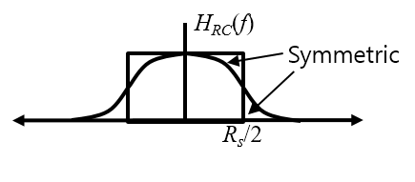

* **Spectrum of RC Pulse**

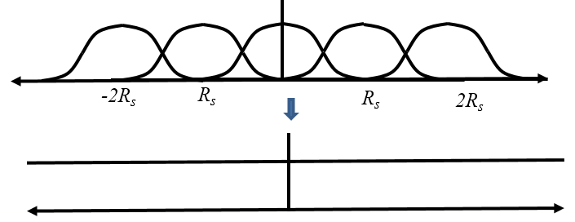

RC pulse has a constant spectrum after sampling. So, RC pulse is most commonly used ISI free pulse.

* **RC Pulse Spectrums with Different Bandwidths**

Minimum BW $W_{\text{min}}=0.5R_{s}$ and  
Excessive BW $W_{\text{EX}}=W-W_{\text{min}}=W-0.5R_{s}$

Roll off factor

$$r≜\frac{W_{\text{EX}}}{W_{\text{min}}}=\frac{W-0.5R_{s}}{0.5R_{s}}$$

where $W$ is Zero to Null Bandwidth.

Note that $H_{RC}\left(±0.5R_{s}\right)=0.5$ irrespective of the roll off factor that is 3dB BW which is 6dB in power spectrum.

* **BW vs. Truncation Error Tradeoff**

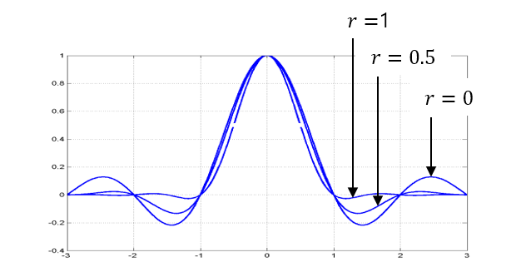

* + Small BW, Small $r$, Large ripples, Large error.
  + Large BW, Large $r$, Small ripples, Small error
* **Square Root Raised Cosine Pulse**

$$h\left(t\right)=h_{t}\left(t\right)*h_{c}\left(t\right)*h_{r}\left(t\right) \\ →H\left(f\right)=H_{t}\left(f\right)H_{c}\left(f\right)H_{r}\left(f\right)$$

Assume the ideal channel, i.e.,

$$h_{c}\left(t\right)=δ\left(t\right)→H_{c}\left(f\right)=1$$

Then, to maximize output SNR of the receiver filter, $h_{t}\left(t\right)$ should be the matched filter to the TX pulse $h_{t}\left(t\right)$, i.e.,

$$h_{t}\left(t\right)=h_{t}^{*}\left(-t\right)→H_{r}\left(f\right)=H_{t}^{*}\left(f\right)$$

Substituting,

$$H\left(f\right)=H_{t}\left(f\right)H_{c}\left(f\right)H_{r}\left(f\right)={\left|H_{t}\left(f\right)\right|}^{2}$$

Note that we design $h_{t}\left(t\right)$, however, $h\left(t\right)$ not $h_{t}\left(t\right)$ should be ISI-free pulse. Hence, ${\left|H_{t}\left(f\right)\right|}^{2}$ should be ISI-free spectrum.

$${\left|H_{t}\left(f\right)\right|}^{2}=H_{RC}\left(f\right)→H_{t}\left(f\right)=\sqrt{H_{RC}\left(f\right)}$$

where $H_{RC}\left(f\right)$ is called square root raised cosine (SRRC) pulse and is denoted by $H_{SRRC}\left(f\right)$

* **Eye Diagram**

Partitioned and overlaid waveforms. Partition length is integer multiples of the symbol duration. Easy to see ISI and visually assess the signaling performance.

|  |  |
| --- | --- |
|  |  |
| Small roll-off factor:  narrow eye opening | Large roll-off factor:  wide eye opening |

* **Why and When the Waveform-level Simulation Needed?**
  + Accommodate the waveform-level effects such as:

Channel effects (multipath fading, clipping, etc.) / Synchronization error (phase, frequency, symbol timing)

* + Accommodate the waveform-assisted (or waveform-level) algorithms such as:

Pulse shaping and matched filtering / Synchronization / Equalization

* + Observe the waveforms

Eye diagram / Constellation / Signal trajectory / Peak to average power ratio (PAPR)

* **Limitations of waveform-level simulation in the computers.**
  + Non-ideally continuous waveforms, i.e., we have to use the sampled versions of the waveforms
  + Careful setting needed for the sampling interval, variance for the sampled version of the noise signal.
* **Noise Rejection Filter**

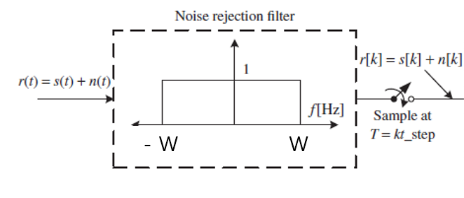To pass the signal $s\left(t\right)$ as is and to reject white noise.

To make the output noise sequence $n\left[k\right]$ be a white Gaussian process, the sapling frequency should be equal to 2W

$$\frac{1}{\text{t_step}}=2W→\frac{1}{2⋅\text{t_step}}=W$$

* **Quaternary Phase Shift Keying (QPSK)**

$$s_{i}\left(t\right)=\sqrt{\frac{2E}{T}}\cos\left(ω_{0}t-ϕ_{i}\right), 0≤t≤T, i=1, 2, 3, 4 \\ =\sqrt{E}\cos\left(ϕ_{i}\right)\sqrt{\frac{2}{T}}\cos\left(ω_{0}t\right)+\sqrt{E}\sin\left(ϕ_{i}\right)\sqrt{\frac{2}{T}}\sin\left(ω_{0}t\right)$$

$$ψ_{1}\left(t\right)=\sqrt{\frac{2}{T}}\cos\left(ω_{0}t\right), ψ_{2}\left(t\right)=\sqrt{\frac{2}{T}}\sin{ω_{0}t}$$

then,

$$s_{i}\left(t\right)=\sqrt{E}\cos\left(ϕ_{i}\right)\sqrt{\frac{2}{T}}ψ_{1}\left(t\right)+\sqrt{E}\sin\left(ϕ_{i}\right)\sqrt{\frac{2}{T}}ψ_{2}\left(t\right)=x\left(t\right)+y\left(t\right)$$

where

$$x\left(t\right)=\left\{\begin{aligned}\sqrt{E_{b}}ψ_{1}\left(t\right), &\text{if} b_{I}=\text{'1'} \\ -\sqrt{E_{b}}ψ_{1}\left(t\right), &\text{if} b_{I}=\text{'0'}\end{aligned}\right. \\ y\left(t\right)=\left\{\begin{aligned}\sqrt{E_{b}}ψ_{1}\left(t\right), &\text{if} b_{Q}=\text{'1'} \\ -\sqrt{E_{b}}ψ_{1}\left(t\right), &\text{if} b_{Q}=\text{'0'}\end{aligned}\right.$$

and $x\left(t\right)$ and $y\left(t\right)$ are BPSK signals. So, QPSK is the summation of two parallel BPSK signals that are orthogonal each other.

It is intuitive that BPSK and QPSK have the identical BER. With identical bandwidth, QPSK has twice data rate than BPSK.

|  |  |  |
| --- | --- | --- |
| 4-ary symbol index $i$ | $$b_{I}b_{Q}$$ | $$ϕ_{i}$$ |
| 1 | 11 | $$π/4$$ |
| 2 | 10 | $$-π/4$$ |
| 3 | 01 | $$3π/4$$ |
| 4 | 00 | $$-3π/4$$ |

* **Pulse Shaped QPSK**
$$s\left(t\right)=I\left(t\right)\sqrt{\frac{2}{T_{s}}}\cos\left(ω_{c}t\right)+Q\left(t\right)\sqrt{\frac{2}{T_{s}}}\sin\left(ω_{c}t\right)=\sqrt{\frac{2}{T_{s}}\left(I^{2}\left(t\right)+Q^{2}\left(t\right)\right)}\cos\left(ω_{c}t-\tan^{-1}\left(\frac{Q\left(t\right)}{I\left(t\right)}\right)\right)$$

* **Offset QPSK (OQPSK)**

To avoid the simultaneous polarity changes of $I\left(t\right)$, and $Q\left(t\right)$, simply insert a delay block into one of $I\left(t\right)$ and $Q\left(t\right)$ signal before multiplying the sinusoids.

* **MPSK Signal Expression**

$$s_{i}\left(t\right)=\sqrt{\frac{2E_{s}}{T}}\cos\left(ω_{c}t-\frac{2π\left(i-1\right)}{M}\right)$$

$$0≤t≤T, i=1,2,…,M$$

$$s_{i}\left(t\right)=\sqrt{E_{s}}\cos\left(\frac{2π\left(i-1\right)}{M}\right)\sqrt{\frac{2}{T}}\cos\left(ω_{c}t\right)+\sqrt{E_{s}}\sin\left(\frac{2π\left(i-1\right)}{M}\right)\sqrt{\frac{2}{T}}\sin\left(ω_{c}t\right)=a_{i1}ψ_{1}\left(t\right)+a_{i2}ψ_{2}\left(t\right)$$

where

$$ψ_{1}\left(t\right)=\sqrt{\frac{2}{T}}\cos\left(ω_{c}t\right), a_{i1}=\sqrt{E_{s}}\cos\left(\frac{2π\left(i-1\right)}{M}\right)$$

$$ψ_{2}\left(t\right)=\sqrt{\frac{2}{T}}\sin\left(ω_{c}t\right), a_{i2}=\sqrt{E_{s}}\sin\left(\frac{2π\left(i-1\right)}{M}\right)$$

thus, in vector space,

$$s_{i}\left(t\right)→{\text{s}}_{i}=\left(a_{i1},a_{i2}\right)=\left(\sqrt{E_{s}}\cos\left(\frac{2π\left(i-1\right)}{M}\right),\sqrt{E_{s}}\sin\left(\frac{2π\left(i-1\right)}{M}\right)\right)$$

* **Symbol Error of MPSK**

$$S_{1}$$

$$S_{2}$$

$$D$$

$$\sqrt{E_{s}}$$

$$ϕ$$

$$ϕ=\frac{1}{2}\left(\frac{2π}{M}\right)=\frac{π}{M}, D=\sqrt{E_{s}}\sin{ϕ}$$

Minimum distance energy

$$E_{d}={\left(2D\right)}^{2}={\left(2\sqrt{E_{s}}\sin{ϕ}\right)}^{2}$$

where $E_{s}=\log_{2}{M}⋅E_{b}$

$$∴E_{d}={\left(2\sqrt{\log_{2}{M}⋅E_{b}}\sin{\frac{π}{M}}\right)}^{2}=4\log_{2}{M}⋅E_{b}\sin^{2}{\frac{π}{M}}\overset{\text{for large M}}{≈}4\log_{2}{M}⋅E_{b}{\left(\frac{π}{M}\right)}^{2}=4E_{b}π^{2}\frac{\log_{2}{M}}{M^{2}}$$

As $M$ increases, $E_{d}$ decrease. Therefore, the symbol error rate increases.

* **Gray mapping**

Neighboring symbols have only 1-bit difference. This reduce bit errors.

* **BER of MPSK**

For large SNR, the errors between the closest symbol pairs in vector space is dominant. So,

$$P_{s}≈Q\left(\frac{D}{\sqrt{{N_{0}}/2}}\right)=Q\left(\frac{{\sqrt{E_{D}}}/2}{\sqrt{{N_{0}}/2}}\right)=Q\left(\sqrt{\frac{E_{D}}{2N_{0}}}\right)$$

$$\text{BER of} P_{s}≈\frac{1}{\log_{2}{M}}P_{s}=\frac{1}{\log_{2}{M}}Q\left(\sqrt{\frac{E_{D}}{2N_{0}}}\right)$$

$$\text{where} E_{d}≈4E_{b}π^{2}\frac{\log_{2}{M}}{M^{2}}$$

There are three assumptions: large SNR, gray-mapped symbols and large $M$.

As $M$ increase, BER of MPSK increases.

$$ω_{c}$$

$$R_{s}\left(1+r\right)$$

$$0.5R_{s}={0.5}/T$$

$$r$$

* **Bandwidth of MPSK**

$$W=R_{s}\left(1+r\right)$$

Where

$$R_{s}=\frac{1}{T}=\frac{1}{\log_{2}{M}⋅T_{b}}=\frac{R_{b}}{\log_{2}{M}}$$

$$r=\text{roll-off factor}, T_{b}=\text{bit duration}, R_{b}=\text{bit rate}$$

thus,

$$W=\frac{R_{b}(1+r)}{\log_{2}{M}}$$

As $M$ increases with a fixed bit rate $R_{b}$, the bandwidth of MPSK decreases.

As $M$ increases with a fixed bandwidth, the bit rate increases.

* **MPSK Demodulator**
$$r\left(t\right)=s_{m}\left(t\right)+n\left(t\right)$$

$$ψ_{1}\left(t\right)$$

$$ψ_{2}\left(t\right)$$

$$\int_{0}^{T}{}$$

$$\int_{0}^{T}{}$$

$$\arctan{\frac{z_{1}}{z_{2}}}$$

$$z_{1}$$

$$z_{2}$$

$$\left|ϕ_{i}-\hat{ϕ}\right|$$

$$\hat{ϕ}$$

$$\hat{m}$$

$$\underset{i}{argmin}$$

* **16QAM Signal**

$$ψ_{1}(t)$$

$$ψ_{2}(t)$$

1

3

3

1

-1

-1

-3

-3

0000

0001

0010

0011

0100

0101

0110

0111

1000

1001

1010

1011

1100

1101

1110

1111

$$E_{s}=\frac{2\left(M-1\right)}{3}=10, E_{b}=\frac{E_{s}}{4}=2.5$$

$$E_{d}=\frac{6\log_{2}{M}}{\left(M-1\right)}E_{b}$$

* **16QAM Demodulator**
$${\hat{b}}_{4}=\left\{\begin{aligned}1, &z_{1}>0 \\ 0, &\text{else}\end{aligned}\right., {\hat{b}}_{3}=\left\{\begin{aligned}1, &\left|z_{1}\right|<2 \\ 0, &\text{else}\end{aligned}\right.$$

$${\hat{b}}_{2}=\left\{\begin{aligned}1, &z_{2}>0 \\ 0, &\text{else}\end{aligned}\right., {\hat{b}}_{1}=\left\{\begin{aligned}1, &\left|z_{2}\right|<2 \\ 0, &\text{else}\end{aligned}\right.$$

* **Bandwidth of QAM** as same as MSPK
* **Bandwidth Efficiency**
$$\text{BW Efficiency}=\frac{\text{Bit rate}}{\text{Bandwidth}}=\frac{R_{b}}{W}=\frac{\log_{2}{M}}{1+r}$$

* **MFSK Signal**
$$s_{i}\left(t\right)=\sqrt{\frac{2E_{s}}{T}}\cos\left(ω_{i}t\right)=\sqrt{\frac{2E_{s}}{T}}\cos\left(ω_{c}t+\left(i-1\right)Δωt\right)$$

$$Δf=\frac{Δω}{2π}=\frac{1}{2T} \text{for coherent MFSK} \\ Δf=\frac{1}{T} \text{for non-coherent MFSK}$$

$$〈s_{i}\left(t\right), s_{j}\left(t\right)〉=\int_{0}^{T}{s_{i}\left(t\right)s_{j}\left(t\right)}dt=0, \text{for} ∀i≠j$$

* **MFSK Demodulator: Coherent**
$$s_{1}\left(t\right)$$

$$s_{M}\left(t\right)$$

$$\int_{0}^{T}{}$$

$$\int_{0}^{T}{}$$

$$r\left(t\right)=$$

$$s_{m}\left(t\right)+n\left(t\right)$$

$$z_{1}$$

$$⋮$$

$$z_{M}$$

$$⋮$$

$$⋮$$

$$z_{1}$$

$$z_{M}$$

$$\underset{i}{argmax}{z_{i}}$$

$$\hat{m}$$

* **MGSK Demodulator: Non-coherent**

This case when the phase of the local carrier is not synchronized to the received signal.

Mathematically equivalent to set

$$r\left(t\right)=\sqrt{\frac{2E}{T}}\cos\left(ω_{m}t+θ\right)+n\left(t\right) \text{where} θ=\text{phase error}$$

$$r\left(t\right)=\sqrt{\frac{2E}{T}}\cos\left(ω_{m}t+θ\right)+n\left(t\right)$$

$$\underset{i}{argmax}{z_{i}}$$

$$\hat{m}$$

$$\sqrt{2/T}\cos{(ω_{1}t)}$$

$$\sqrt{2/T}\sin{(ω_{1}t)}$$

$$\int_{0}^{T}{}$$

$$\int_{0}^{T}{}$$

$$z_{11}$$

$$z_{12}$$

$${\left(\right)}^{2}$$

$${\left(\right)}^{2}$$

$$\sqrt{2/T}\cos{(ω_{2}t)}$$

$$\sqrt{2/T}\sin{(ω_{2}t)}$$

$$\int_{0}^{T}{}$$

$$\int_{0}^{T}{}$$

$$z_{21}$$

$$z_{22}$$

$${\left(\right)}^{2}$$

$${\left(\right)}^{2}$$

$$z_{1}$$

$$z_{2}$$

* **Error performance and BW of MFSK**

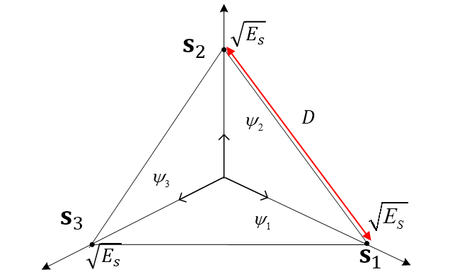

$$E_{d}=D^{2}=2E_{s}=2\log_{2}{M}⋅E_{b}$$

Note that as $M$ increases, $E_{d}$ increases. Therefore, better BER performance.

* **Bandwidth of MFSK**

$$W⋅Δf=\left\{\begin{aligned}\frac{M}{2T}=\frac{M}{2T_{b}\log_{2}{M}}=\frac{MR_{b}}{2\log_{2}{M}}, &\text{coherent} \\ \frac{MR_{b}}{\log_{2}{M}}, &\text{non=coherent}\end{aligned}\right.$$

Note that as $M$ increases, $W$ increases.

* **Rayleigh Fading**

$$r=hs+n$$

where $s$ is complex plane representation for 2D modulated signal.

$$s=s_{1}+js_{2}, E_{s}=E\left[{\left|s\right|}^{2}\right]$$

where $n$ is complex Gaussian noise.

$$n=n_{1}+jn_{2}, n_{1},n_{2}\sim N(0,\frac{N_{0}}{2})$$

$n_{1}$ and $n_{2}$ are independent each other.

where $h$ is signal scaling coefficient due to fading.

$$h=z+jy, z, y\sim N\left(0,\frac{1}{2}\right)$$

$z$ and $y$ are i.i.d. Gaussian.

* **Rayleigh Fading Decision Variable**

$$D=re^{-j∠h}=\left(hs+n\right)e^{-j∠h}=\left(\left|h\right|e^{j∠h}s+n\right)e^{-j∠h}=\left|h\right|s+ne^{-j∠h}$$

where signal term $\left|h\right|s$ has the same phase as that of the original symbol $s$.

* **PDF of $\left|h\right|$**

$$f_{\left|h\right|}\left(x\right)=\left\{\begin{aligned}2xe^{-x^{2}}, &x≥0 \\ 0, &x<0\end{aligned}\right.$$



This is called Rayleigh distribution.

* **Instantaneous Symbol Energy**

$${\left|h\right|}^{2}E_{s}$$

where ${\left|h\right|}^{2}$ is instantaneous symbol energy scaling term. Denote this scaling term as a new RV $c={\left|h\right|}^{2}$.

Under Rayleigh fading, instantaneous symbol energy is given by

$$E_{i}={\left|h\right|}^{2}E_{s}$$

* **PDF of $c$**



$$f_{c}\left(x\right)=\left\{\begin{aligned}e^{-x}, &x≥0 \\ 0, &x<0\end{aligned}\right.$$

This is called Exponential distribution

* **Average Instantaneous Symbol Energy**

$$\overline{E_{i}}=E\left[{\left|h\right|}^{2}\right]⋅E_{s}=E\left[c\right]⋅E_{s}$$

where

$$E\left[c\right]=\int_{-∞}^{∞}{xf_{c}\left(x\right)}dx=\int_{-∞}^{∞}{xe^{-x}}dx=1$$

So, $\overline{E_{i}}=E_{s}$

* **Average BER under Rayleigh Fading**

$$p_{b}=E_{c}\left[Q\left(\sqrt{\frac{2cE_{b}}{N_{0}}}\right)\right]=\int_{-∞}^{∞}{Q\left(\sqrt{\frac{2xE_{b}}{N_{0}}}\right)f_{c}\left(x\right)}dx=\int_{0}^{∞}{\left(\int_{\frac{2xE_{b}}{N_{0}}}^{∞}{\frac{e^{{-t^{2}}/2}}{\sqrt{2π}}}dt\right)e^{-x}}dx=\frac{1}{2}\left(1-\sqrt{\frac{E_{b}/N_{0}}{1+{E_{b}}/{N_{0}}}}\right)$$

|  |
| --- |
| clear  syms c EbN0 positive  instantBER = 0.5 * (1-erf(sqrt(c * EbN0)));  BER_fading = int(instantBER * exp(-c), c, 0, inf);  Pretty((BER_fading)) |
| >>  1 sqrt(EbN0)  - - --------------------  2 2sqrt(EbN0 + 1) |

if ${E_{b}}/{N_{0}}→1$

$$p_{b}=\frac{1}{2}\left(1-\sqrt{\frac{\frac{E_{b}}{N_{0}}}{1+{E_{b}}/{N_{0}}}}\right)≈\frac{1}{4{E_{b}}/{N_{0}}}$$

in log scale,

$$p_{b}=\log\left(\frac{1}{4γ}\right)=\log\left(\frac{1}{4}\right)-\log{γ}=\log\left(\frac{1}{4}\right)-0.1\left(10\log{{E_{b}}/{N_{0}}}\right)=-6-0.1\left({E_{b}}/{N_{0}}\left[\text{dB}\right]\right)$$

* **Selection Diversity Combining (SDC)**

$$k_{\text{best}}=\underset{k}{argmax}\left|h\left(k\right)\right|$$

$$D=γ\left(k_{\text{best}}\right)e^{-j∠\left(k_{\text{best}}\right)}$$

The branch with the largest fading coefficient is selected for detection and the rest are not used.

When $\left|h\left(1\right)\right|, \left|h\left(2\right)\right|, ⋯, \left|h\left(L\right)\right|$ are similar, the considerable symbol energies distributed in the unselected branches are missed.

* **Equal Gain Combining (EGC)**

$$D=\sum_{k=1}^{L}{γ\left(k\right)e^{-j∠h\left(k\right)}}=\left|h\left(1\right)\right|s+n^{'}\left(1\right)+\left|h\left(2\right)\right|s+n^{'}\left(2\right)+⋯+\left|h\left(k\right)\right|s+n^{'}\left(k\right)=\left(\left|h\left(1\right)\right|+\left|h\left(2\right)\right|+⋯+\left|h\left(k\right)\right|\right)s+\left(n^{'}\left(1\right)+n^{'}\left(1\right)+⋯+n^{'}\left(k\right)\right)$$

The term prior to performing summation is required so that the fading coefficients are coherently summed.

The relatively noisy (=relatively small h) branches contribute rather destructively to the overall SNR of $D$.

* **Maximum Ratio Combining (MRC)**

$$D=\sum_{k=1}^{L}{g\left(k\right)γ\left(k\right)e^{-j∠h\left(k\right)}}→\sum_{k=1}^{L}{g_{opt}\left(k\right)γ\left(k\right)e^{-j∠h\left(k\right)}}=\sum_{k=1}^{L}{α\left|h\left(k\right)\right|γ\left(k\right)e^{-j∠h\left(k\right)}}=α\sum_{k=1}^{L}{\left|h\left(k\right)\right|e^{-j∠h\left(k\right)}γ\left(k\right)}=α\sum_{k=1}^{L}{h^{*}\left(k\right)γ\left(k\right)}$$

Large $g\left(k\right)$ to the reliable branches.

Small $g\left(k\right)$ to the noisy branches.

We can show that the optimal gains are proportional to the channel fading magnitude.

$$g_{opt}\left(k\right)=α\left|h\left(k\right)\right|$$

where $α$ is any arbitrary positive real number.

* **Optimal Combining Gain**

$$D=\sum_{k=1}^{L}{g\left(k\right)e^{-j∠h\left(k\right)}γ\left(k\right)}=\sum_{k=1}^{L}{g\left(k\right)e^{-j∠h\left(k\right)}\left(h\left(k\right)s+n\left(k\right)\right)}=\sum_{k=1}^{L}{g\left(k\right)\left|h\left(k\right)\right|s}+\sum_{k=1}^{L}{g\left(k\right)n{\left(k\right)}^{e^{-j}∠h\left(k\right)}s}$$

$$\text{SNR}=\frac{\text{Signal }{\text{term}}^{2}}{\text{Variance of noise term}}=\frac{{\left(\sum_{k=1}^{L}{g\left(k\right)\left|h\left(k\right)\right|s}\right)}^{2}}{\frac{N_{0}}{2}\sum_{k=1}^{L}{g^{2}\left(k\right)}}=\frac{2s^{2}}{N_{0}}⋅\frac{{\left|〈\text{G}, \text{H}〉\right|}^{2}}{{\left|\text{G}\right|}^{2}}$$

Inner product is maximized when two vectors have the same angle.

$$\text{G}=α\text{H}$$